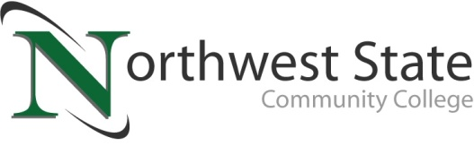

DATE: August 17, 2023
CONTACT: Jim Bellamy 419.267.1267 jbellamy@NorthwestState.edu

NORTHWEST STATE COMMUNITY COLLEGE CENTER HOSTS FREDERICK SHEGOG
FOR SPECIAL PRESENTATIONS OF HOPE AND PERSEVERANCE

Archbold, Ohio – Northwest State Community College hosted esteemed motivational speaker Frederick “Freddy” Shegog to its Archbold campus on August 16th for a series of presentations to learners, faculty and staff. Mr. Shegog shared his personal journey of overcoming major obstacles of homelessness and addiction to become a college graduate and renowned motivational speaker. It was especially meaningful for NSCC, as Freddy's higher education journey began at a community college. The presentations came a week prior to the start of the fall semester at NSCC, and the day of the Fall Kickoff event for new and returning learners on campus.

ABOUT FREDDY SHEGOG
From Freddy’s website (https://freddyshegog.com), “Frederick Shegog is a man who knows all too well about the struggles of this world. In his early twenties, he watched his future dreams fade away as substance use disorder and mental illness took over his life. The next decade of his life would be a rough one, but not only would he come out better from it- he would devote his life to helping others overcome as well.”

The website bio continues, “In 2018 Frederick founded his own motivational-speaking company, The Message LLC. He started this company to make a difference in the world and "sell hope for a living." Frederick's "What is your legacy?" keynote has been sought nationwide and nationally recognized at some of the most prestigious academic conferences. His speaking portfolio displays depth, wisdom, and ability to connect with various audiences. Frederick took these blessings and expanded the company by offering consulting services. He now sits in rooms of policy consulting with educators, philanthropists, and legislators. Education changed Frederick's life, and he states, ‘College did not only change my bank account, it changed my soul as well!’” The NSCC campus community greatly appreciates Freddy for sharing his time and his inspirational message.

Those interested in discovering great hands-on training and education at Northwest State are encouraged to visit NorthwestState.edu online, or call the NSCC admissions team at 419.267.1320 today. Fall semester begins August 23.

###

Northwest State Community College is an accredited two-year, state-assisted institution of higher education that has served northwest Ohio since 1969. Northwest State is committed to providing a quality, affordable education with personal attention and small class sizes. The College offers associate degrees with numerous transfer options, short-term certificate programs, and workforce training programs designed to meet the needs of local businesses and industries. For more information, visit NorthwestState.edu or call 419.267.5511.

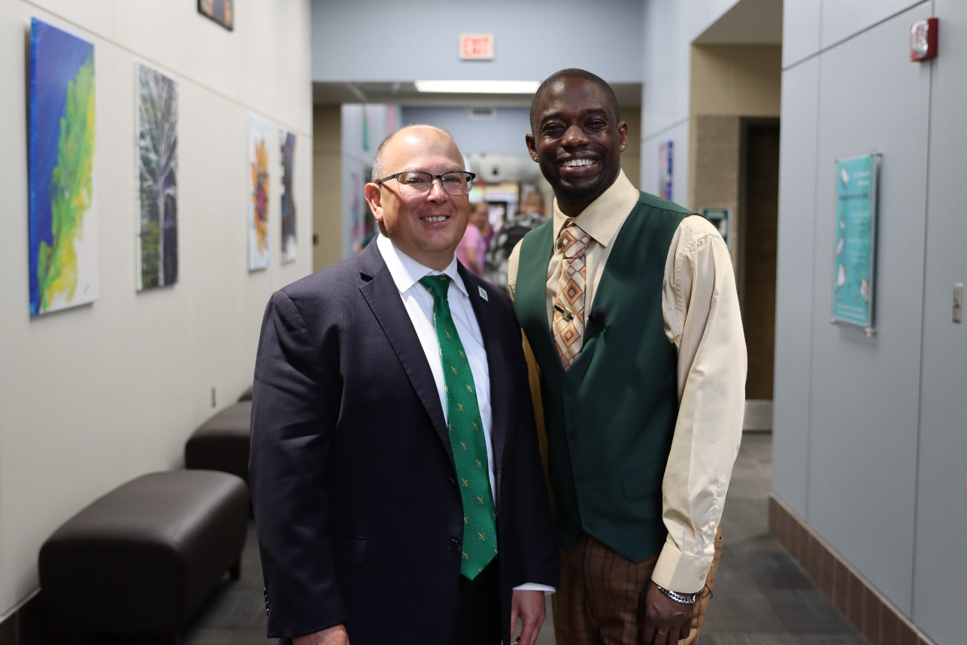

Pictured L to R: Dr. Todd Hernandez (NSCC President) and Freddy Shegog

