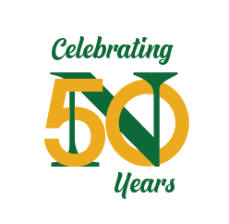
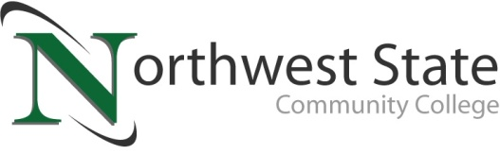

Media Advisory
Date: May 13, 2021
Contact: Jim Bellamy, 419.267.1267 jbellamy@NorthwestState.edu

Northwest state community college GREEN CARPET EVENT /
“MAKING A DIFFERENCE AWARDS”
Thursday, May 20th, 6:00 p.m.

Archbold, Ohio –

Who: Area media members

What: The NSCC Foundation will recognize and celebrate one business, organization and individual in the six-county area committed to bettering their community. This year’s recipients of the “Making a Difference Awards” include Terry Henricks Chrysler Dodge Jeep Ram, Farm Bureau Fulton, Henry, Williams & Defiance Counties, and Dan Yahraus (Bryan Chamber). Only award winners and their families / colleagues will be in attendance, while the event will be broadcast virtually on https://northweststate.edu/live.

When: Thursday, May 20, 2021. Media interviews for the “Making a Difference Award” winners will begin at 4:45 p.m. outside the Auditorium. The Green Carpet program will begin at 6:00 p.m. for in-person guests, and the live stream of the entire program will begin at 7:00 p.m. for the general public.

Where: The video will be presented for public viewing beginning at 7:00 p.m. on NorthwestState.edu/live.

facts: Proceeds from the Green Carpet event benefit student scholarships. This year’s “Making a Difference Award” winners include Terry Henricks Chrysler Dodge Jeep Ram, Farm Bureau Fulton, Henry, Williams & Defiance Counties, and Dan Yahraus (Bryan Chamber). For more information, contact Robbin Wilcox at 419.267.1460 or rwilcox@NorthwestState.edu. More information on the event is available online at https://northweststate.edu/green-carpet.

###

Northwest State Community College is an accredited two-year, state-assisted institution of higher education that has served northwest Ohio since 1969. Northwest State is committed to providing a quality, affordable education with personal attention and small class sizes. The College offers associate degrees with numerous transfer options, short-term certificate programs, and workforce training programs designed to meet the needs of local businesses and industries. For more information, visit NorthwestState.edu or call 419.267.5511.

