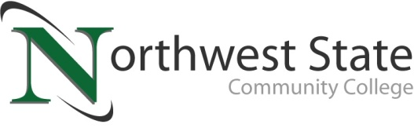

Media Advisory

Date: April 6, 2023
Contact: Jim Bellamy, 419.267.1267 jbellamy@NorthwestState.edu

Northwest state community college SCHOLARSHIP AWARDS RECEPTION
Thursday, April 20th, 6:00 p.m.

Archbold, Ohio –

Who: Area media members available to attend

What: The NSCC Foundation will award scholarships for the academic year of ’23-‘24 at our Scholarship Awards Reception.

When: Thursday, April 20, 2023 at 6:00 p.m.

Where: The event will be held in person at the Archbold Campus, in the Atrium area.

facts: The NSCC Foundation offers more than 45 scholarships for Northwest State students, with scholarships ranging from $250 to full tuition. Some scholarships are awarded to multiple students each year. In 2022, the NSCC Foundation awarded just over $1 million in scholarships to students throughout northwest Ohio. In 2023, Foundation scholarships totaling approximately $760,000 will be awarded to students. Please note: A post-event press release will also be sent to all area media.

###

Northwest State Community College is an accredited two-year, state-assisted institution of higher education that has served northwest Ohio since 1969. Northwest State is committed to providing a quality, affordable education with personal attention and small class sizes. The College offers associate degrees with numerous transfer options, short-term certificate programs, and workforce training programs designed to meet the needs of local businesses and industries. For more information, visit NorthwestState.edu or call 419.267.5511.

Media AdvisorY

