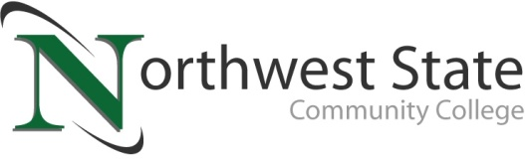

DATE: April 18, 2023
CONTACT: Jim Bellamy 419.267.1267 jbellamy@NorthwestState.edu

NORTHWEST STATE CELEBRATES ENTREPRENEURSHIP AT ITS
9TH ANNUAL ENTREPRENEURSHIP FORUM ON TUESDAY, MAY 9

Archbold, Ohio – Northwest State Community College celebrates the spirit of entrepreneurship and the power of small businesses in hosting its 9th annual Entrepreneurship Forum on Tuesday, May 9 from 4:00-6:00 p.m. in the Voinovich Auditorium. This FREE event is open to all residents of Defiance, Fulton, Henry, Paulding and Williams Counties with a business idea and want help in moving it forward.

VALUABLE EXPERIENCES
The 2023 Entrepreneurship Forum provides budding entrepreneurs the opportunity to present their ideas to a panel of experts from the region, and to network with those experts – both very valuable experiences. Premier Bank and The State Bank & Trust Company will sponsor four state registration fees to open small businesses at the event as well! Local economic development directors and lenders from the five county area will make up the advisory panel.

REMOVING BARRIERS
“Northwest State, the Small Business Development Center, and economic development are joining forces to invigorate small business growth in Northwest Ohio. Small business is vital to our communities. We need entrepreneurs to keep things going,” said Lisa Becher, business faculty at Northwest State. Becher is also the State of Ohio Small Business Development Center Consultant in NW Ohio and a local business owner. She has created a “semi-Shark Tank style” event that helps aspiring business owners by removing barriers to market. “The forum was created to break down barriers and move entrepreneurs forward, helping them with an idea. Many people just don't know what to do next and how to get started. It is a wonderful networking opportunity to meet with lenders and economic development to fast forward their concept,” Becher continued.

HOW TO REGISTER
People can register for the Entrepreneurship Forum by emailing Lisa Becher at lbecher@NorthwestState.edu or NWOhioSBDC@gmail.com. Registration is required for everyone and free of charge. Space is limited, and a virtual presentation option exists for those who prefer to present remotely. “Free consultation services will be provided by the Small Business Development Center,” Becher said. Additional information on this event is available online at NorthwestState.edu/events.

###
Northwest State Community College is an accredited two-year, state-assisted institution of higher education that has served northwest Ohio since 1969. Northwest State is committed to providing a quality, affordable education with personal attention and small class sizes. The College offers associate degrees with numerous transfer options, short-term certificate programs, and workforce training programs designed to meet the needs of local businesses and industries. For more information, visit NorthwestState.edu or call 419.267.5511.

