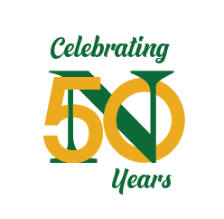
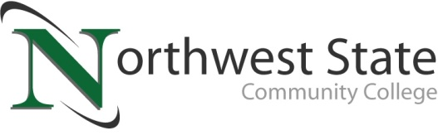

Date: April 24, 2023
Contact: Jim Bellamy | 419.267.1267 | jbellamy@northweststate.edu

NSCC FOUNDATION AWARDS NARLY $800,000 in FOUNDATION scholarships

Archbold, Ohio – On Thursday, April 20th, the Northwest State Community College Foundation recently proudly awarded nearly $800,000 in scholarships to 298 students from the region. The event shined a spotlight on “giving back,” offering needed financial help to students through the generosity of donors to the NSCC Foundation.

“We were blessed to host another spectacular Scholarship Awards event for our community,” said Robbin Wilcox, Executive Director of Development & the NSCC Foundation. “We are so proud of our learners’ accomplishments, and we are grateful for the generosity of our donors – they epitomize what ‘giving back’ is all about,” Wilcox noted.

The event kicked off with opening remarks by NSCC President Dr. Todd Hernandez and NSCC Foundation Board member Kevin Whitlock (1996 NSCC grad), each providing congratulatory remarks to both students and gratitude to the donors who make the Foundation scholarships possible. Tim Kline (1977 NSCC grad and 1998 Distinguished Alumni), the founder and former President/CEO for CK Technologies, provided the Donor perspective.

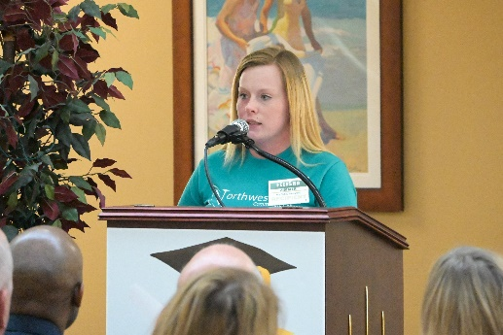
AMAZING STUDENT STORY
Felisha Zimmer (Human Services major) provided the student perspective, sharing her perseverance and overcoming almost overwhelming obstacles, including drug and alcohol abuse, and incarceration. “I finally had enough of going through the same things and being nothing. I needed to take all my downfalls and everything I’ve experienced in life and make it worth something. I started recognizing my worth and that I had a purpose in life,” Zimmer commented. Zimmer is a recipient of the Troy Richey Scholarship, and the Changing Lives Scholarship.

ABOUT THE NSCC FOUNDATION
The NSCC Foundation was established in 1978 to provide support for the students, people and programs of NSCC. For over 40 years, the Foundation has remained true to its mission to enhance, expand and sustain Northwest State so that NSCC can continue to fulfill its mission of creating opportunities for transformational learning. The NSCC Foundation works diligently to raise much-needed funds for educational opportunities that directly and indirectly impact students. “The NSCC Foundation continues to work hard each year to increase funding to support our students through both scholarships and efforts to provide state of the art training equipment,” noted Wilcox. She added, “The NSCC Foundation is not only giving nearly $800,000 in scholarship dollars this year, but they are also helping the College to develop and expand programs that will help both students and our business partners for generations to come.” Additional information about the NSCC Foundation is available at NorthwestState.edu/foundation.

###
Northwest State Community College is an accredited two-year, state-assisted institution of higher education that has served northwest Ohio since 1969. Northwest State is committed to providing a quality, affordable education with personal attention and small class sizes. The College offers associate degrees with numerous transfer options, short-term certificate programs, and workforce training programs designed to meet the needs of local businesses and industries. For more information, visit NorthwestState.edu or call 419.267.5511.

PLEASE NOTE: A FULL LIST OF SCHOLARSHIP RECIPIENTS IS INCLUDED AS AN EXCEL LIST WITH THIS EMAIL.
SELECT MEDIA IMAGES FROM THE EVENT ARE AVAILABLE AT
https://northweststate.smugmug.com/20230420-NSCC-Scholarship-Awards-MEDIA/

