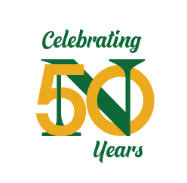
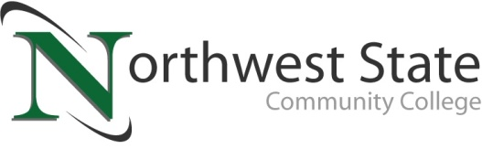

DATE: May 5, 2023
CONTACT: Jim Bellamy | 419.267.1267 | jbellamy@NorthwestState.edu

Northwest state community college SPRING COMMENCEMENT
Saturday, May 13, 2022 at 2:00 p.m. at Founder’s Hall (Archbold)

Archbold, Ohio –

Who: Graduates, family members, faculty and staff of Northwest State Community College will attend the Spring Commencement Ceremony. Media are invited to cover the event.

What: NSCC President Todd Hernandez will welcome the spring 2023 Commencement of Northwest State Community College. Dr. Michael Thomson (former President of Northwest State Community College) will offer the Commencement address. 225 students will be receiving a total of 238 degrees and/or certificates.

When: Saturday, May 14, 2021 at 2:00 p.m.
NOTE NEW LOCATION: Founder’s Hall (Archbold)
Event is also available on the College’s YouTube channel – YouTube.com/user/NorthwestStateCC

facts: 225 Graduates will be recognized for their achievements. Dr. Michael Thomson (former President of Northwest State Community College), will offer the Commencement address. The event will be held in-person at Founder’s Hall in Archbold. Those unable to attend can watch the ceremony on the College’s official YouTube page, YouTube.com/user/NorthwestStateCC.

###
Northwest State Community College is an accredited two-year, state-assisted institution of higher education that has served northwest Ohio since 1969. Northwest State is committed to providing a quality, affordable education with personal attention and small class sizes. The College offers associate degrees with numerous transfer options, short-term certificate programs, and workforce training programs designed to meet the needs of local businesses and industries. For more information, visit NorthwestState.edu or call 419.267.5511.

