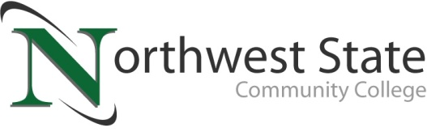

Date: June 12, 2023
Contact: Jim Bellamy | 419.267.1267 | jbellamy@NorthwestState.edu

NORTHWEST STATE ANNOUNCES NEW ARTICULATION AGREEMENT
WITH PURDUE FORT WAYNE

Archbold, Ohio – Northwest State Community College and Purdue University Fort Wayne are excited to announce a new partnership that will benefit current and future students of both schools. Starting July 1, 2023, graduates from Northwest State may transfer up to 66 college credits toward a Bachelor of Applied Science degree at Purdue Fort Wayne. Articulation agreements such as this help students by simplifying the transfer process from a community college to the 4-year university of their choice.

Purdue Fort Wayne’s Bachelor of Applied Science degree is designed for students who have already received their associate degree, and are looking to further their education in the academic areas of business, leadership and supervision, information systems, or information technology. PFW offers on-campus, online, and hybrid classes designed to accommodate all student schedules.

Jason Rickenberg, Dean of Business & Public Services for Northwest State, noted “This articulation agreement is an extension of our partnership with Purdue Fort Wayne. Graduates of Northwest State Community College can now transfer credits from both the Associate of Applied Science and the Associate of Applied Business programs to a very prestigious Midwestern university”.

“We at Northwest State are continuously working to increase educational access for all our student populations. Agreements such as this allow current and future students the opportunity to take classes locally, and at a much-reduced price, then seamlessly continue their career path to a 4-year institution,” said Dr. Todd Hernandez, president of Northwest State Community College.

“With the planning of Northwest State’s Van Wert campus, and most certainly the proximity to Fort Wayne, partnerships help strengthen educational opportunities for our students in Paulding and Van Wert counties. As our Van Wert campus comes to fruition in 2024, we will continue to expand access to students in northwest Ohio,” said Dr. Jon Tomlinson, Dean of Northwest State’s Van Wert Campus.

While the Van Wert campus at 520 E. Sycamore St. (former Kennedy Manufacturing building) is slated to open in fall of 2024, NSCC is continuing to offer on-site courses in Van Wert at OhioHealth Van Wert Hospital and its full suite of online program offerings via the main campus. The next round of classes will begin on August 23, 2023. The full course offering schedule for fall semester can be found by visiting NorthwestState.edu/VanWert. Questions can be directed to Dr. Jon Tomlinson by emailing jtomlinson@northweststate.edu, or visiting NSCC’s storefront location at 122 N. Washington Street.

About Purdue University Fort Wayne
Purdue University Fort Wayne is the largest university in northeast Indiana and is part of the Purdue University system. Purdue Fort Wayne is uniquely positioned to serve the region as a crossroads of intellectual, social, economic, and cultural advancement. Rigorous academics are combined with a focus on student success across prestigious degree programs taught by more than 300 full-time faculty. 8,093 students of diverse ages, ethnicities, and nationalities pursue their education on the nearly 600-acre campus. A majority of the university’s 62,000+ alumni live and work in Indiana contributing significantly to the state’s economy, vitality, and intellectual strength. The university is a member of the Horizon League athletics conference, and fields 16 NCAA Division I sports teams. For more information, visit pfw.edu.

About Northwest State Community College
Northwest State Community College is an accredited two-year, state-assisted institution of higher education that has served northwest Ohio since 1969. Northwest State is committed to providing a quality, affordable education with personal attention and small class sizes. The College offers associate degrees with numerous transfer options, short-term certificate programs, and workforce training programs designed to meet the needs of local businesses and industries. For more information, visit NorthwestState.edu or call 419.267.5511.

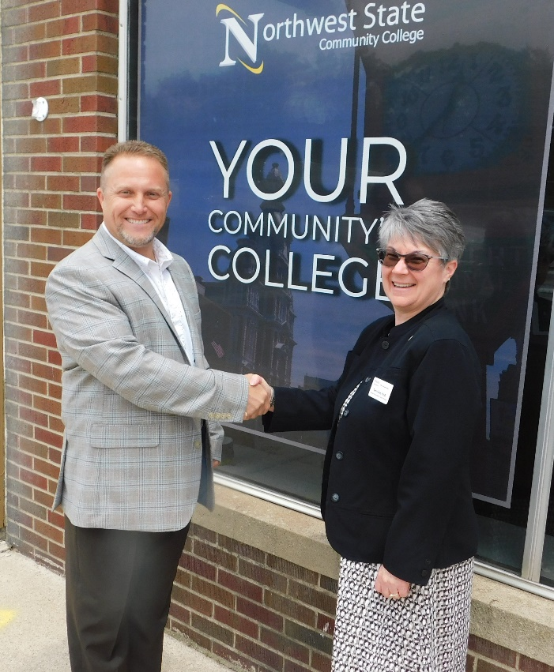
###

>>> Pictured: Dr. Jon Tomlinson, Dean of the Van Wert Campus; Dr. Terri Swim, Associate Vice Chancellor for Academic Programs, Purdue Fort Wayne

