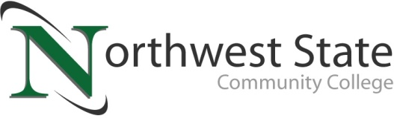

DATE: July 24, 2023
CONTACT: Jim Bellamy 419.267.1267 jbellamy@NorthwestState.edu

NSCC ANNOUNCES 2019 NCLEX PASS RATES
FOR NURSING PROGRAM GRADUATES

Archbold, Ohio – The need for skilled nurses continues to grow nationwide, and Northwest State Community College is leading the way in preparing students to meet the healthcare demands of our communities. The Registered Nursing graduates from 2023 at NSCC earned a 100% pass rate for the National Council Licensure Exam (NCLEX).

QUOTABLES
“Northwest State Community College is proud to announce the outstanding success of its nursing graduates on the NCLEX nursing boards for the second quarter of 2023. The pass rate for the Associate Degree Registered Nurses is at an amazing 100%!” said Dr. Tiffany Ludwig, Dean of Nursing and Allied Health at NSCC.

Ludwig continued, “The NCLEX nursing boards is a critical milestone for graduating nurses, serving as an adaptive test that is required for nursing graduates to successfully pass to be licensed as a Registered Nurse. NSCC prepares their students for job readiness and gives students the tools they need to have a successful career. The accomplishment of the students reflects the dedication of our nursing students, as well as the faculty and staff and their support.”

“These results show that NSCC students, faculty, and staff all have shown commitment and hard work and have proven that perseverance pays off. Enroll today to begin your nursing career and join the amazing team here at NSCC,” Ludwig noted.

EDUCATION THAT PAYS
Nursing careers are hard work, but are also potentially lucrative, which makes the NSCC education worth the time and effort. According to the Bureau of Labor Statistics (www.bls.gov), the mean annual wage from May 2022 for a Registered Nurse is $89,010.

Both the practical nursing and registered nursing programs are accepting applications at Northwest State’s main campus in Archbold. For more information on NSCC healthcare programs, as well as other degree and certificate programs, the “Bachelor’s Bound” transfer option and more, visit NorthwestState.edu or call NSCC Admissions at 419.267.1320.

###

Northwest State Community College is an accredited two-year, state-assisted institution of higher education that has served northwest Ohio since 1969. Northwest State is committed to providing a quality, affordable education with personal attention and small class sizes. The College offers associate degrees with numerous transfer options, short-term certificate programs, and workforce training programs designed to meet the needs of local businesses and industries. For more information, visit NorthwestState.edu or call 419.267.5511.

https://www.bls.gov/oes/current/oes291141.htm

