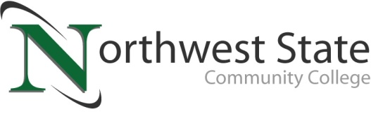

DATE: October 23, 2023
CONTACT: Jim Bellamy 419.267.1267 jbellamy@NorthwestState.edu

NORTHWEST STATE COMMUNITY COLLEGE HONORS AREA VETERANS WITH
FREE VETERANS LUNCHEON ON NOVEMBER 9TH

Archbold, Ohio – Northwest State Community College invites area veterans to enjoy a complimentary Veterans Luncheon on Thursday, November 9th, starting at 11:30 a.m. in the Voinovich Auditorium on the College’s Archbold campus. NSCC currently has approximately 39 student-veterans pursuing coursework, credentialing, certificates and/or associate degrees.

NSCC President Dr. Todd Hernandez, a US Navy veteran, will open the event with remarks. As a highlight of the event, Kerry Patrick Clark will provide his heartwarming blend of music and storytelling, and Staff Sergeant Steve Wing will provide a special presentation about his time in the Vietnam War.

RSVP BY NOVEMBER 7th
Those interested in attending are asked to RSVP by Tuesday, November 7th to Olof Fleming in the NSCC Foundation office – phone 419.267.1351 or email ofleming@NorthwestState.edu. Additional information on NSCC events is available any time online at NorthwestState.edu/events.

###

Northwest State Community College is an accredited two-year, state-assisted institution of higher education that has served northwest Ohio since 1969. Northwest State is committed to providing a quality, affordable education with personal attention and small class sizes. The College offers associate degrees with numerous transfer options, short-term certificate programs, and workforce training programs designed to meet the needs of local businesses and industries. For more information, visit NorthwestState.edu or call 419.267.5511.

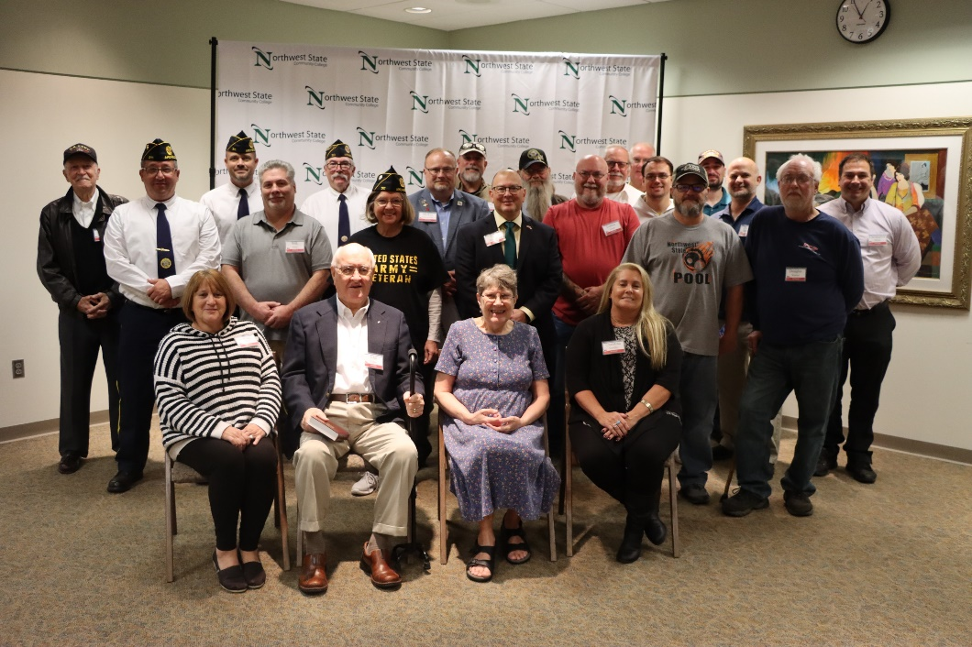
2022 NSCC Veterans Luncheon group photo

