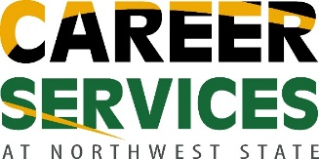
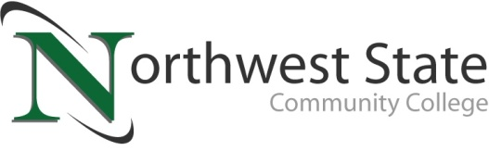

DATE: March 22, 2023
CONTACT: Jim Bellamy 419.267.1267 jbellamy@NorthwestState.edu

NORTHWEST STATE TO HOST FREE JOB & CAREER FAIR
ON TUESDAY, APRIL 4

Archbold, Ohio – Area job seekers have an opportunity to network with 80 employers at a community-wide Job & Career Fair on Tuesday, April 4 from 10:30 a.m.-2:00 p.m. The event will be held in the Atrium at Northwest State Community College and is presented by NSCC Career Services. The Job & Career Fair is free and open to the public.

“This year, we will have 80 area businesses looking to fill full-time, part-time and seasonal positions, as well as internships. This event is a great opportunity for community members, NSCC students and alumni to connect with those businesses,” said Mike Jacobs, Career Services Coordinator at NSCC. “Preparation is key for any job seeker, especially at an event like this. Attendees should bring several copies of their resume, dress in professional attire and be prepared with a brief ‘sales pitch’ covering their skills and experience.”

Industries that will be represented at the 2023 Job & Career Fair include healthcare, manufacturing, human services, financial, business and more. Additional information is available at NorthwestState.edu/job-fair. For more information, call NSCC Career Services at 419.267.1330 or email careerservices@NorthwestState.edu.

###

Northwest State Community College is an accredited two-year, state-assisted institution of higher education that has served northwest Ohio since 1969. Northwest State is committed to providing a quality, affordable education with personal attention and small class sizes. The College offers associate degrees with numerous transfer options, short-term certificate programs, and workforce training programs designed to meet the needs of local businesses and industries. For more information, visit NorthwestState.edu or call 419.267.5511.

