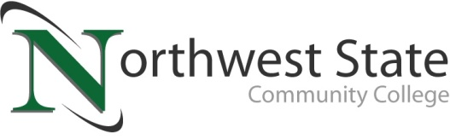

Date: June 16, 2023
Contact: Jim Bellamy, 419.267.1267, jbellamy@NorthwestState.edu

NORTHWEST STATE ANNOUNCES SPRING 2023 DEAN’S LIST

ARCHBOLD, OHIO – Northwest State Community College has announced its spring semester dean’s list. To be eligible, students must have taken at least 12 credit hours as a full-time student, or 6-11.99 as a part-time student, and have averaged above a 3.5 GPA on a 4.0 scale.

###
Northwest State Community College is an accredited two-year, state-assisted institution of higher education that has served northwest Ohio since 1969. Northwest State is committed to providing a quality, affordable education with personal attention and small class sizes. The College offers associate degrees with numerous transfer options, short-term certificate programs, and workforce training programs designed to meet the needs of local businesses and industries. For more information, visit NorthwestState.edu or call 419.267.5511.

NOTE: The complete list is attached to the email as an .xlsx (Excel) file, to help you quickly sort and copy/paste as needed.

