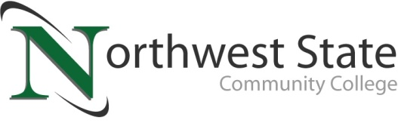

DATE: August 23, 2023
CONTACT: Jim Bellamy 419.267.1267 jbellamy@NorthwestState.edu

NORTHWEST STATE COMMUNITY COLLEGE VOTED
“TOP COMMUNITY COLLEGE IN OHIO”

Archbold, Ohio – Northwest State Community College was recently voted “Top Community College in Ohio” according to WalletHub’s 2023 Best & Worst Community Colleges rankings. A total of 15 Ohio community colleges were included in the WalletHub rankings, which considered a total of 668 American Association of Community Colleges (AACC) member schools. News of the prestigious accolade was originally shared via Cleveland.com.

ABOUT THE WALLETHUB RANKINGS
Per the Cleveland.com article, “(the) rankings were conducted by measuring and comparing three equally weighted categories: Cost & Financing, Education Outcomes, and Career Outcomes. The three categories considered a number of metrics, including cost of in-state tuition and fees; average amount of grant or scholarship aid received; per-pupil spending; first-year retention rate; graduation rate; median salary after attending; and more.”

The entire community colleges list from WalletHub can be found here. NSCC is ranked #1 in Ohio, with a total score of 52.44, and ranked #410 nationally.

NSCC President Dr. Todd Hernandez said, “We are humbled and honored to be named ‘Top Community College in Ohio.’ The factors used in determining the rankings are areas of emphasis every day for our amazing faculty and staff. We work hard to provide equitable access to all learners, and offer holistic services so they can develop a plan, stick to the plan, and complete the plan. We have awarded nearly $2 million in Foundation scholarships the last two years, and we are fully invested in our campus community. We will continue to help our six-county service area discover great opportunities at Northwest State.”

Students interested in job skills training, short-term certificates, two-year degrees, or even a great transfer pathway to a four-year school are encouraged to get started at NSCC today! Contact our admissions team at 419.267.1320, visit NorthwestState.edu online, or just stop by!

###

Northwest State Community College is an accredited two-year, state-assisted institution of higher education that has served northwest Ohio since 1969. Northwest State is committed to providing a quality, affordable education with personal attention and small class sizes. The College offers associate degrees with numerous transfer options, short-term certificate programs, and workforce training programs designed to meet the needs of local businesses and industries. For more information, visit NorthwestState.edu or call 419.267.5511.

https://www.cleveland.com/news/2023/08/the-15-best-community-colleges-in-ohio-ranked.html

