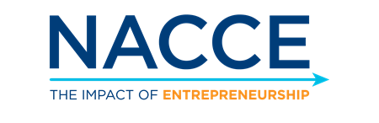
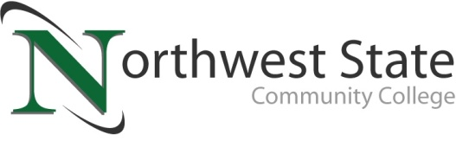

DATE: October 26, 2023
CONTACT: Jim Bellamy 419.267.1267 jbellamy@NorthwestState.edu

NORTHWEST STATE JOINS NACCE’S EVERYDAY ENTREPRENEUR PROGRAM
TO FOSTER INNOVATION AND ENTREPRENEURSHIP

Archbold, Ohio – Northwest State Community College (NSCC), a leading institution in northwest Ohio, is excited to announce its participation in the National Association for Community College Entrepreneurship's (NACCE) Everyday Entrepreneur Program. This collaboration marks a significant step forward in our commitment to promoting innovation and entrepreneurship within our college community.

The Everyday Entrepreneur Program provides community colleges the support needed to provide access to entrepreneurial education and funding for their students to take their businesses from an idea to a thriving enterprise. By partnering with the National Association of Community College Entrepreneurship Everyday Entrepreneur Program we can offer the opportunity for students to take part in pitch competitions and access to entrepreneurial education.

Key highlights of our participation in the NACCE Everyday Entrepreneur Program include:

- Curriculum Enhancement: NSCC will integrate entrepreneurship-focused coursework and hands-on learning opportunities into our academic programs, ensuring that our students are well-prepared to tackle real-world challenges.
- Faculty Development: We will invest in professional development for our faculty, equipping them with the latest tools and resources to deliver high-quality entrepreneurship education.
- Student Support: NSCC will provide mentorship, networking opportunities, and access to resources to help our students turn their entrepreneurial ideas into reality. Students will have access to the Everyday Entrepreneur Program pitch competition prize money.
- Community Engagement: We are committed to collaborating with local businesses and organizations to create a vibrant entrepreneurial ecosystem that benefits our students and the wider community.

NSCC is currently enrolling for the spring 2024 semester. To learn more about Northwest State Community College's participation in the NACCE Everyday Entrepreneur Program, and the business programs available at NSCC, please visit NorthwestState.edu or contact Lisa Becher (NSCC business faculty) at lbecher@NorthwestState.edu or 419.267.1264.

About NACCE:
The National Association for Community College Entrepreneurship (NACCE) is a 501(c) (3) organization dedicated to promoting entrepreneurship through community colleges by providing resources and support to build and sustain high-impact entrepreneurship programs. The association represents 340+ community and technical colleges, universities and HBCU's including over 2,000 faculty, staff, administrators, and presidents who serve more than three million students.
For more information, visit nacce.com.

###

Northwest State Community College is an accredited two-year, state-assisted institution of higher education that has served northwest Ohio since 1969. Northwest State is committed to providing a quality, affordable education with personal attention and small class sizes. The College offers associate degrees with numerous transfer options, short-term certificate programs, and workforce training programs designed to meet the needs of local businesses and industries. For more information, visit NorthwestState.edu or call 419.267.5511.

