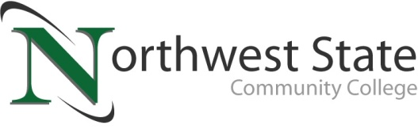

DATE: November 3, 2023
CONTACT: Jim Bellamy 419.267.1267 jbellamy@NorthwestState.edu

NORTHWEST STATE COMMUNITY COLLEGE CENTER FOR LIFELONG LEARNING
TO HOST PROGRAM ON FULTON COUNTY MUSEUM

Archbold, Ohio – The NSCC Center for Lifelong Learning is offering a special presentation on the Fulton County Museum and Welcome Center, featuring John Swearingen, Jr. The program will be held at Northwest State on Friday, November 17th from 9:00 a.m. to noon in room C200. The cost to attend this event is $14.00.

The Museum and Welcome Center opened on May 5, 2018, and is a starting point for exploring and discovering Fulton County, Ohio’s natural, cultural and historical resources. The museum structure, which is a re-creation of the first county courthouse, honors the pioneer families of the county by telling their stories (including the famous race car driver Barney Oldfield).

RESERVE YOUR SPOT TODAY!
Register by Monday, November 13th to reserve your spot. A full hot breakfast begins at 9:00 a.m., and the speaker follows at approximately 9:30 a.m. To sign up today, call Deb Wikstrom at 419.944.6195, or email lifelong@NorthwestState.edu. For more information on the CFLL, and other upcoming programs, please visit NorthwestState.edu/lifelong-learning.

###

Northwest State Community College is an accredited two-year, state-assisted institution of higher education that has served northwest Ohio since 1969. Northwest State is committed to providing a quality, affordable education with personal attention and small class sizes. The College offers associate degrees with numerous transfer options, short-term certificate programs, and workforce training programs designed to meet the needs of local businesses and industries. For more information, visit NorthwestState.edu or call 419.267.5511.

