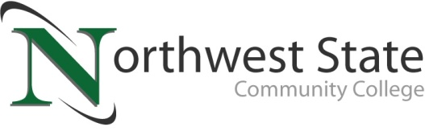

DATE: November 20, 2023
CONTACT: Jim Bellamy 419.267.1267 jbellamy@NorthwestState.edu

NORTHWEST STATE COMMUNITY COLLEGE DONATES
$826 TO THE PATH CENTER FROM CHILI COOK-OFF

Archbold, Ohio – Northwest State Community College Student Activities recently held its 28th Annual Chili Cook-Off in the College’s atrium. Each year, money raised from this event is donated to the PATH Center in Defiance, to be used for area residents in need of assistance. The 2023 event proceeds totaled $826, which were recently donated to representatives from the PATH Center.

OVER $13,000 HAS BEEN RAISED…
The Chili Cook-Off has raised over $13,000 for the PATH Center over the nearly 30 years of the event. This year, eight teams competed in the event. Congratulations to STEMi--people’s choice winner and “golden ladle” winner and also to Heartburn Lane (CTS)--judge’s non-traditional choice and STEMi, again, for Judge’s traditional choice.

QUOTABLE
NSCC Career Services and Student Activities Coordinator Mike Jacobs commented, “Apart from Commencement, the Cook Off is the longest running event in the College's history. People love to be a part of tradition, especially one that has such a positive impact on the community.”

###

Northwest State Community College is an accredited two-year, state-assisted institution of higher education that has served northwest Ohio since 1969. Northwest State is committed to providing a quality, affordable education with personal attention and small class sizes. The College offers associate degrees with numerous transfer options, short-term certificate programs, and workforce training programs designed to meet the needs of local businesses and industries. For more information, visit NorthwestState.edu or call 419.267.5511.

PIC from left to right: Kelsey Peterson, Jamie Huber, Mikyla Garcia, Tobi Fleischman (all employees of the Path Center), and NSCC representatives Mike Jacobs and Kristine Robertson.

