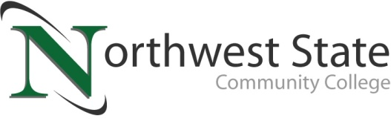

DATE: December 14, 2022
CONTACT: Jim Bellamy 419.267.1267 jbellamy@NorthwestState.edu

Northwest state community college FALL COMMENCEMENT
Monday, December 19, 2022 at 7:00 p.m.

Archbold, Ohio –

Who: Graduates, family members, friends, faculty and staff of Northwest State Community College are invited to attend the fall 2022 Commencement Ceremony at the Voinovich Auditorium. Media members are welcome to attend to cover the event – please RSVP to jbellamy@northweststate.edu.

What: NSCC President Dr. Todd Hernandez will welcome the fall 2022 Commencement of Northwest State Community College. Shirley Wagner, Licensed Funeral Director and Embalmer in the State of Ohio (and NSCC alum), will offer the Commencement address. 103 students will be receiving a total of 106 degrees and/or certificates (83 associate degrees, 23 certificates).

When: Monday, December 19, 2022 at 7:00 p.m.
In-person Commencement ceremony at the Voinovich Auditorium. Ceremony will also be available for viewing as a live stream on the College’s official YouTube channel: YouTube.com/NorthwestStateCC

facts: 103 Graduates will be recognized for their achievements. Shirley Wagner will be the featured Commencement speaker. Please note: seating is limited in the Auditorium. Guests unable to attend the ceremony in person are invited to enjoy a free live-stream of the Commencement ceremony on the College’s official YouTube channel: YouTube.com/NorthwestStateCC.

**A post-event press release with images and the graduate media listing will be sent separately**

###
Northwest State Community College is an accredited two-year, state-assisted institution of higher education that has served northwest Ohio since 1969. Northwest State is committed to providing a quality, affordable education with personal attention and small class sizes. The College offers associate degrees with numerous transfer options, short-term certificate programs, and workforce training programs designed to meet the needs of local businesses and industries. For more information, visit NorthwestState.edu or call 419.267.5511.

