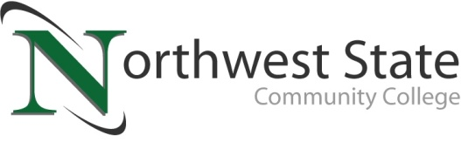

DATE: August 4, 2021
CONTACT: Jim Bellamy | 419.267.1267 | jbellamy@NorthwestState.edu

NSCC PRACTICAL NURSING, PHLEBOTOMY AND MEDICAL ASSISTING
GRADUATES CELEBRATED AT CEREMONY

ARCHBOLD, OHIO – Seven students from Northwest State Community College’s practical nursing program celebrated completion of the program recently during a special pinning ceremony. Graduates are eligible to take the National Council Licensure Exam for Practical Nursing and upon successful completion, enter directly into the workforce. After obtaining work experience, they may continue their education and pursue a degree in registered nursing.

During the ceremony, the College also recognized eight students from the College’s phlebotomy technician certificate program, and one graduate from the medical assisting degree program. Both options lead to entry-level positions in the health care field, and students earning the phlebotomy technician certificate may choose to continue their education for an associate degree in medical assisting.

Practical Nursing students recognized:
Henry County: Noah Gaucin (Napoleon)
Lucas County: Brittany Hunt (Maumee)
Paulding County: Raquel Gomez-Garcia (Paulding)
Putnam County: Traci Rue (Continental), Faith Troyer (Continental)
Van Wert County: Madison Chastain (Scott), Mykayla Olds (Van Wert)

Phlebotomy students recognized:
Defiance County: Lauren Johnston (Defiance), Brittany Moore (Defiance), Summer Wagner (Defiance)
Henry County: Betsey Myers (Napoleon), Courtney Tolles (Deshler)
Williams County: Gabriella Barker (Bryan), Bailee Eck-Speelman (Bryan), Melissa French (Montpelier)

Medical Assisting student recognized:
Defiance County: Melissa Elias (Defiance)

###

NOTES:
- Mykayla Olds was the only PN student available for photography.
- Lauren Johnston was the lone Phlebotomy student unavailable for photography.
- High-res images are available on our Smugmug page for media publication. Visit https://northweststate.smugmug.com/20210803-Nursing-Allied-Health-pinning-MEDIA/ to access photos, should not require a user/pass. Please do not share this link!!

